# **Gradient Descent**

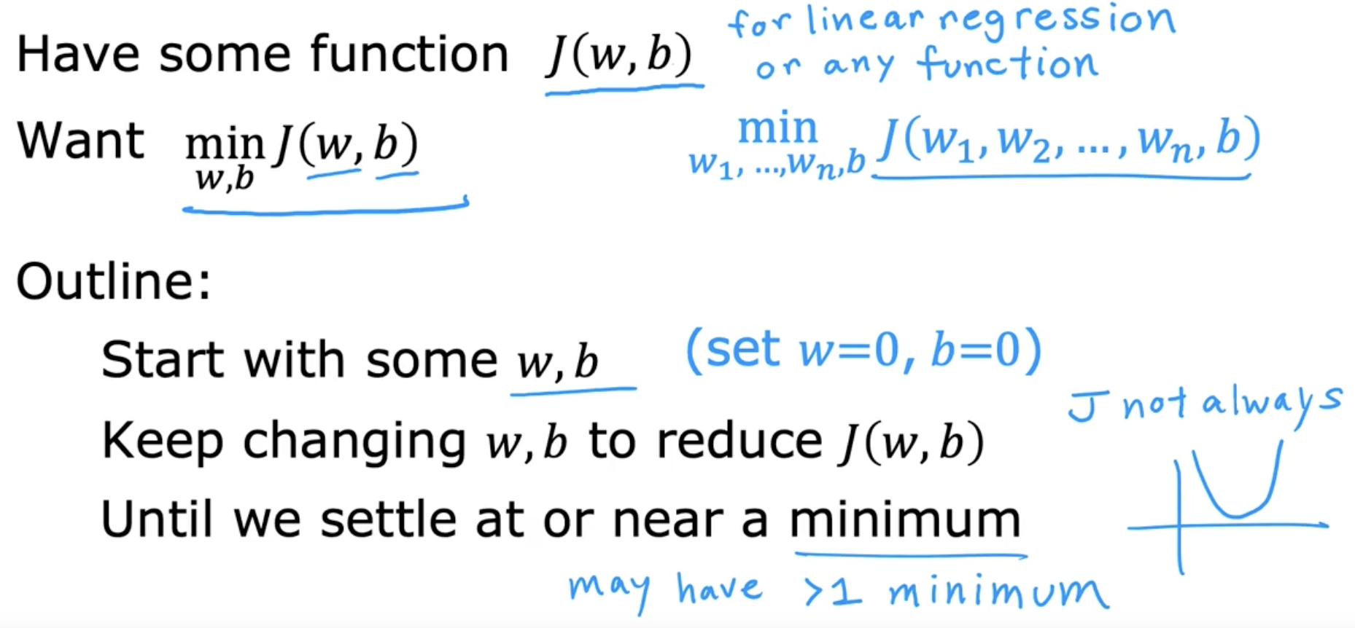

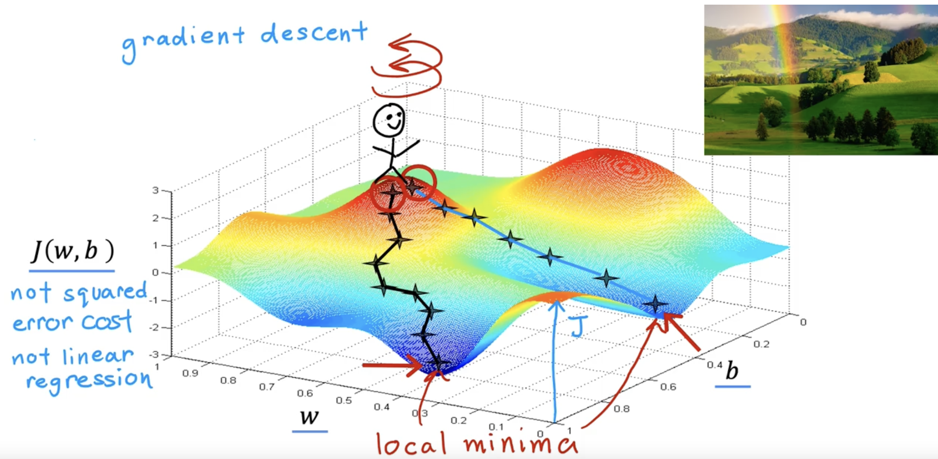

For each and every step, you will look around at 360 degree and decides to go in which direction.

# **Implementing gradient descent**

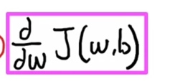

🡪 After looking around for 360 degree, Which direction to go ??



🡪 How many steps you would take in that particular direction ??

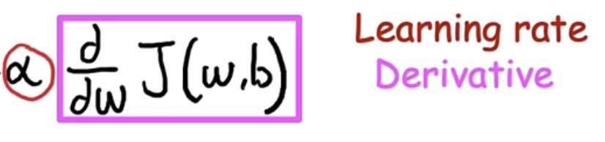 🡪 Steps take in a particular direction

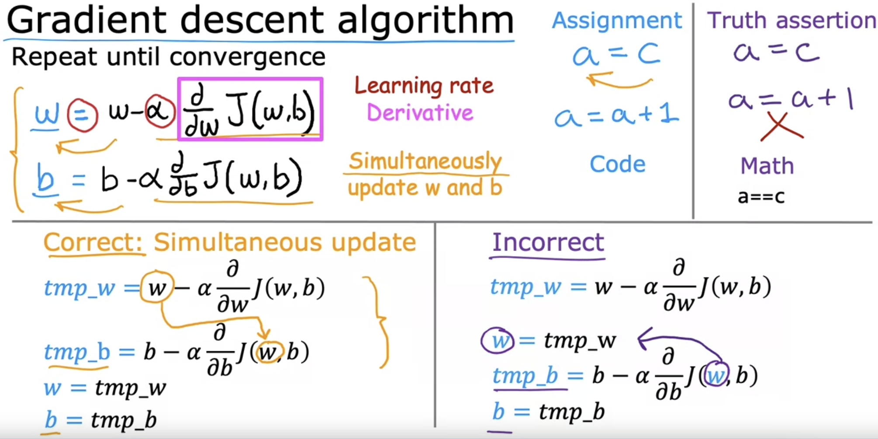

temp_b takes the old w value temp_b takes the updated w value

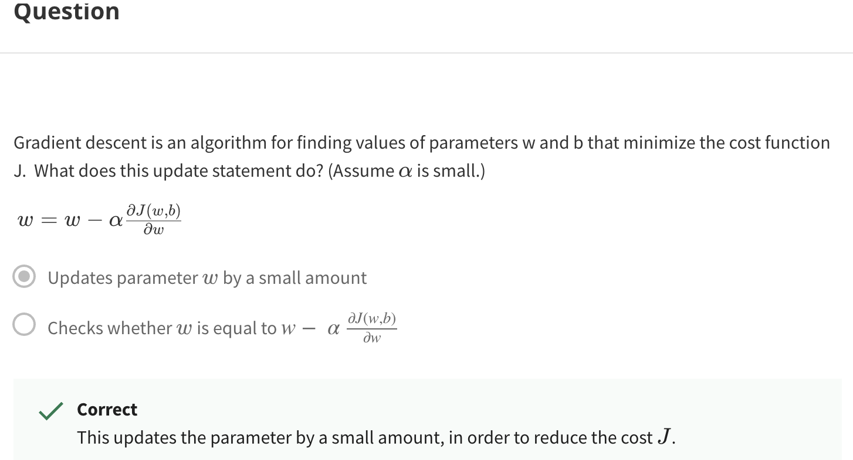

# **Gradient Descent Intuition**

Now starting value of w is too high. Will get a positive slope. So w is reducing.

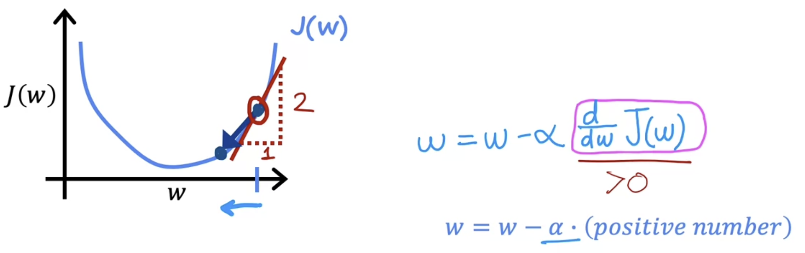

Now starting value of w is too low. Will get a negative slope. So w is increasing.  
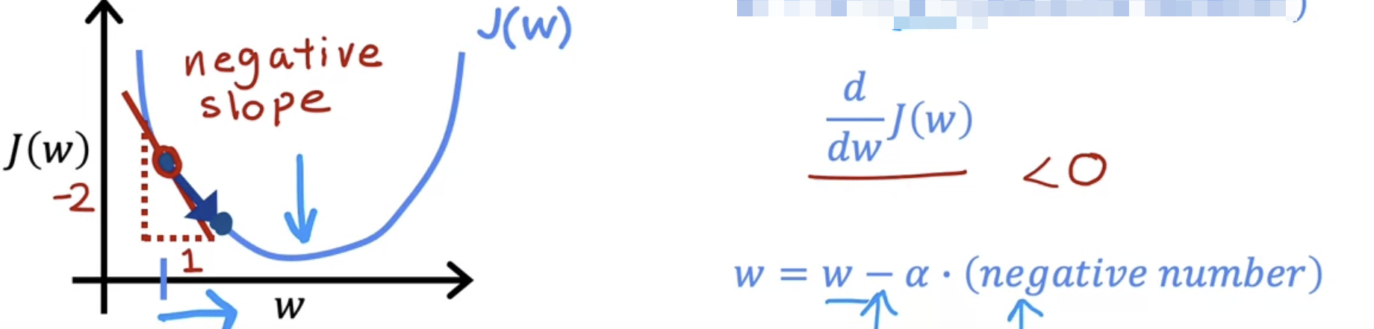

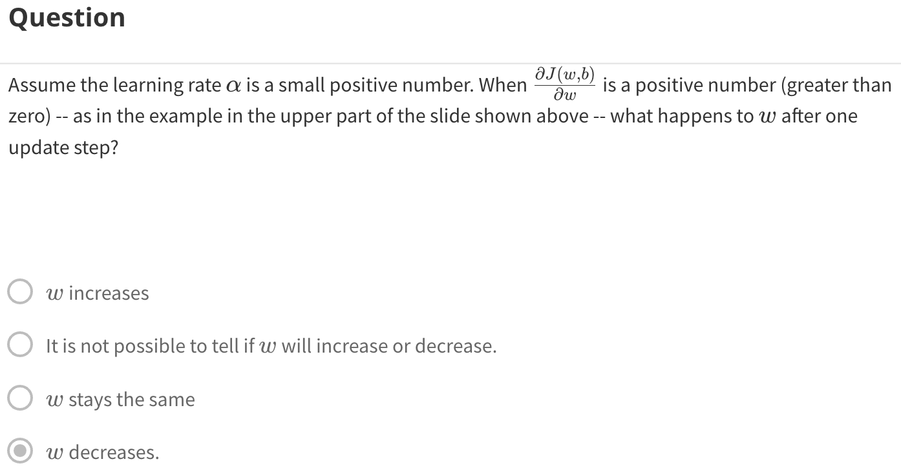  
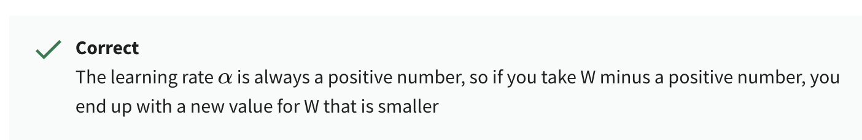

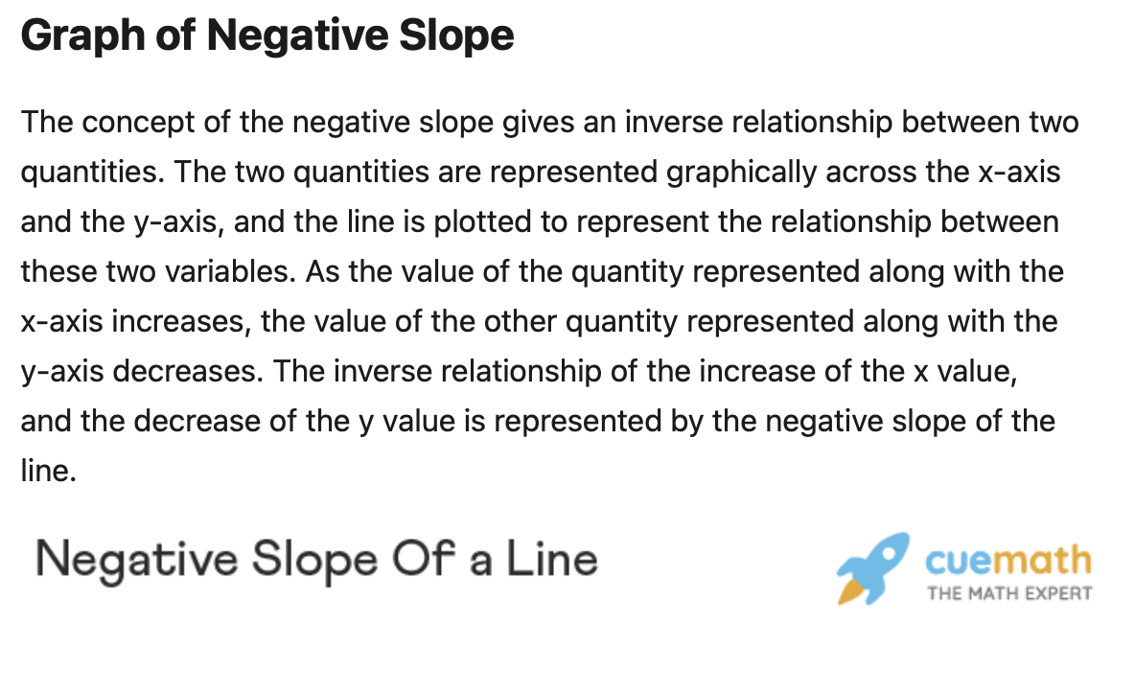  
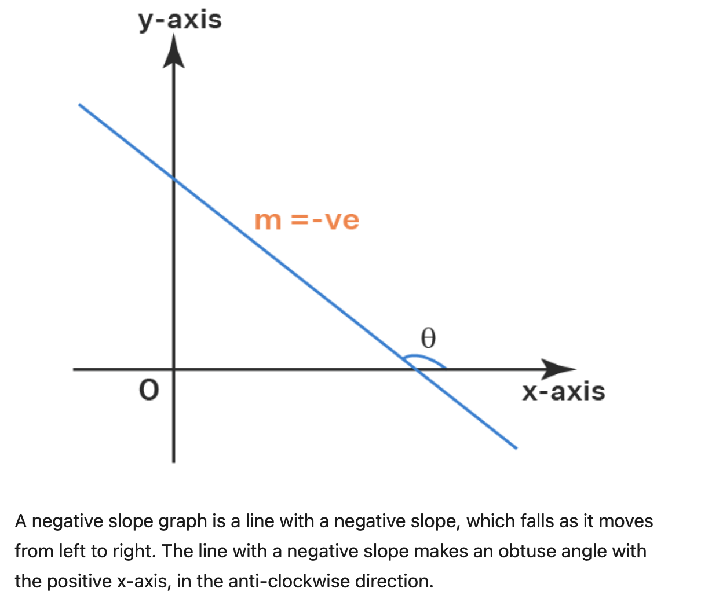

# **Learning Rate**

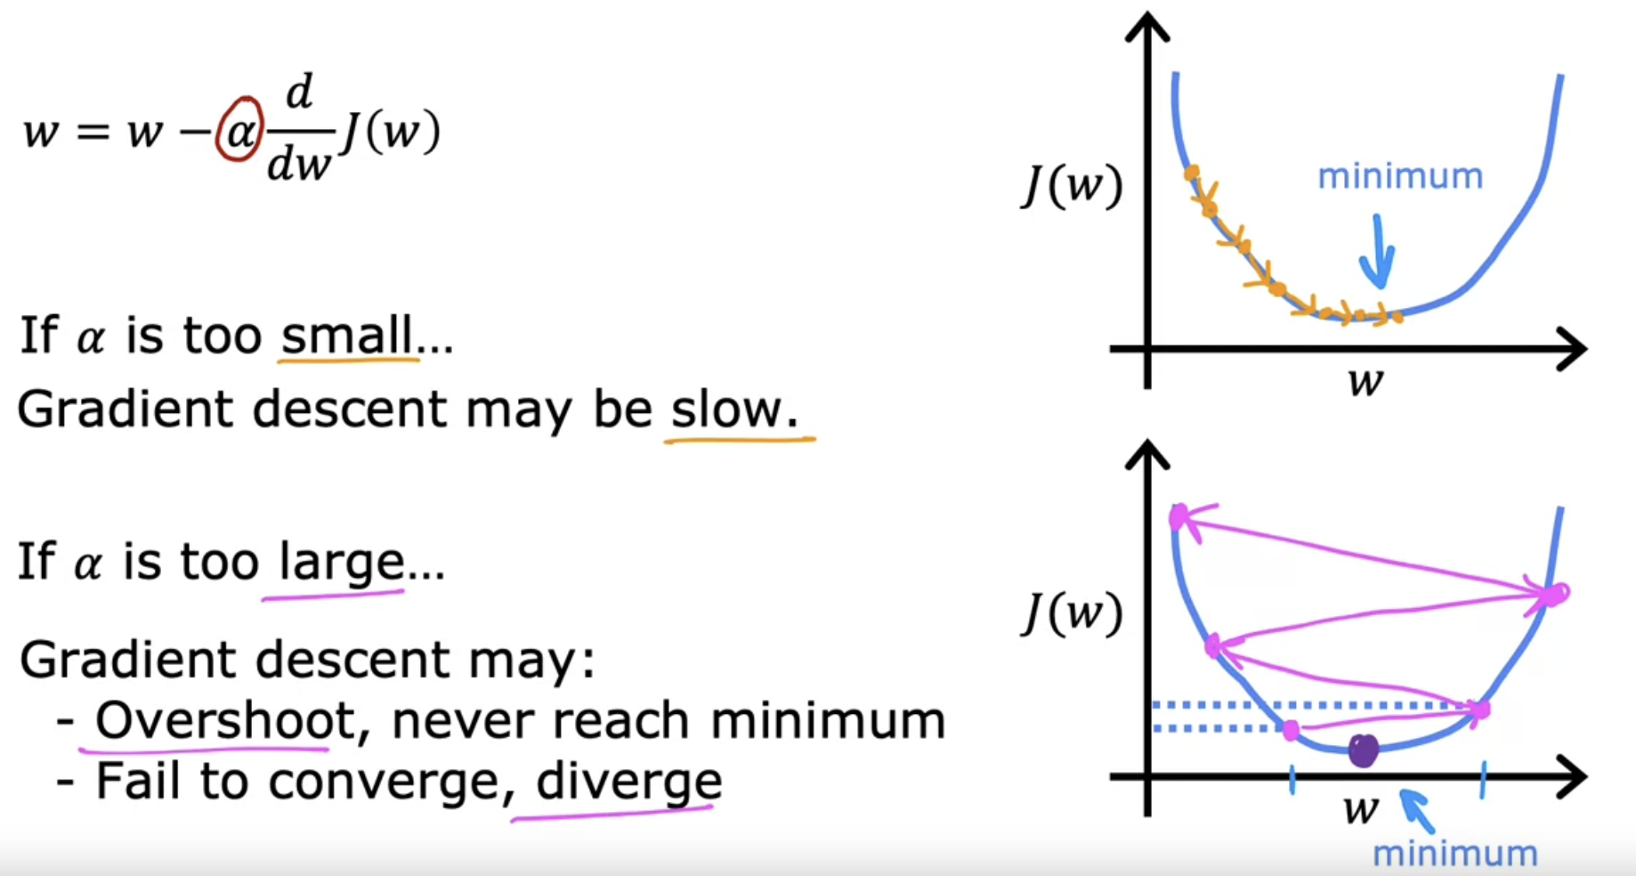

When the w is already at the local minimum ??

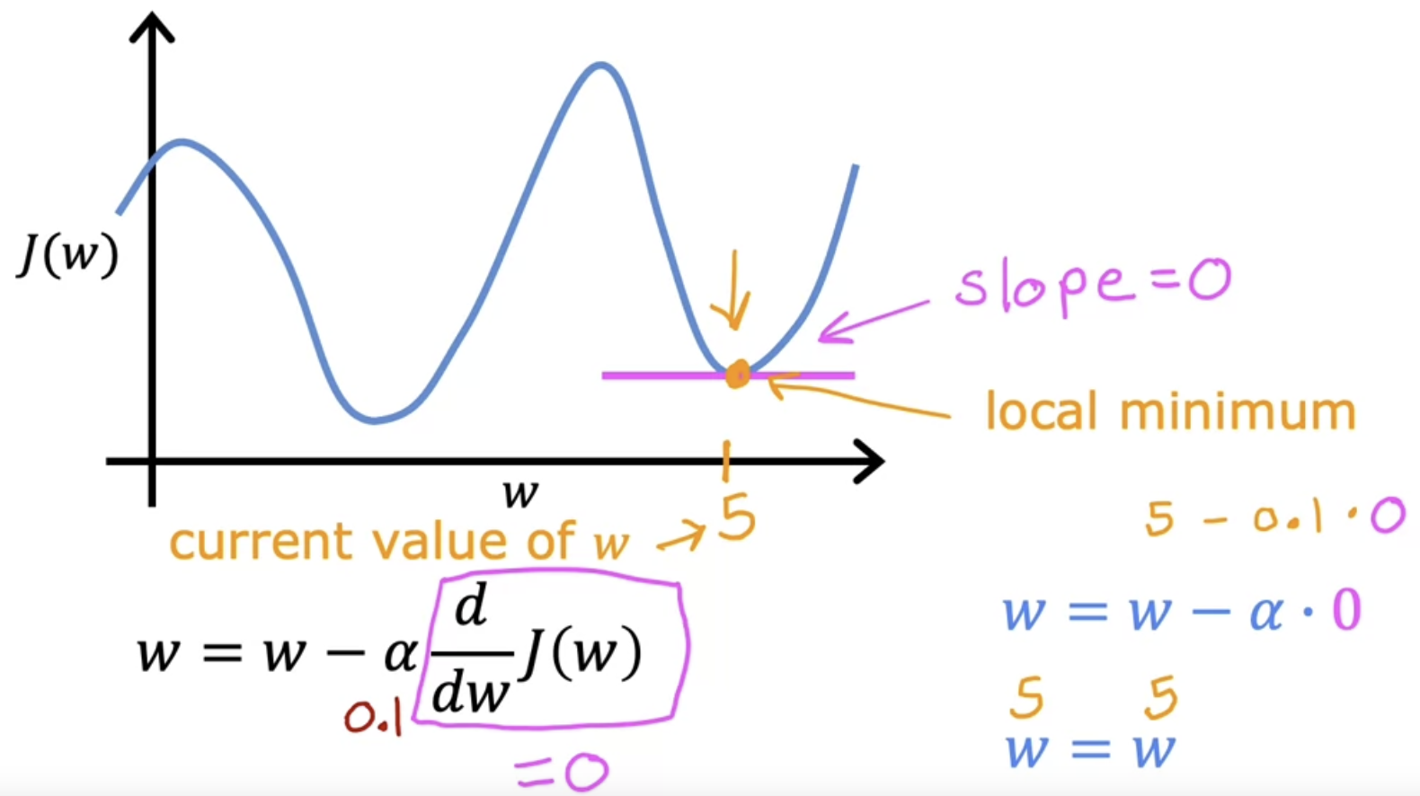

So gradient descent makes w remains unchanged

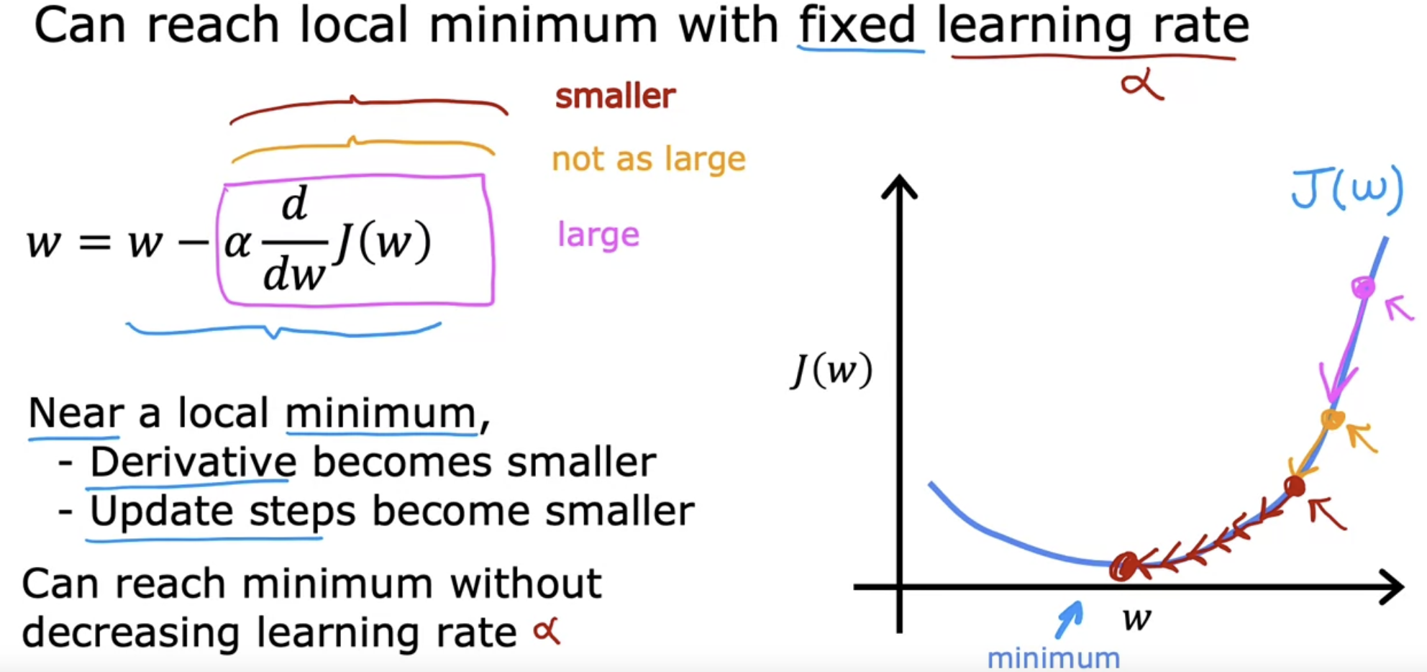

pink 🡪 slope is large, So derivative is also large, So large step.  
orange 🡪 slope is small, So derivative is also small, So small step.

Red 🡪 slope is too small, So derivative is also too small, So too small step.

So as we approach the minimum. The derivative gets closer and closer to zero.

So as we run gradient descent, eventually we're taking very small steps until you finally reach a local minimum.

# **Gradient Descent for Linear Regression**

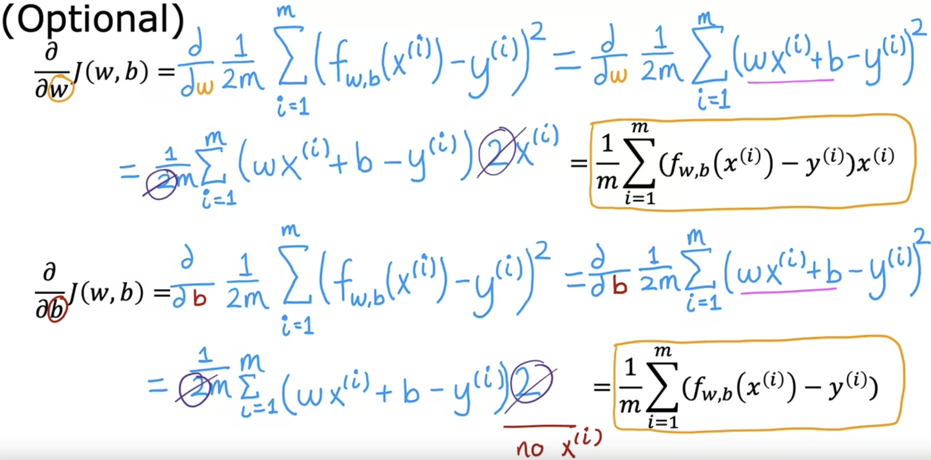

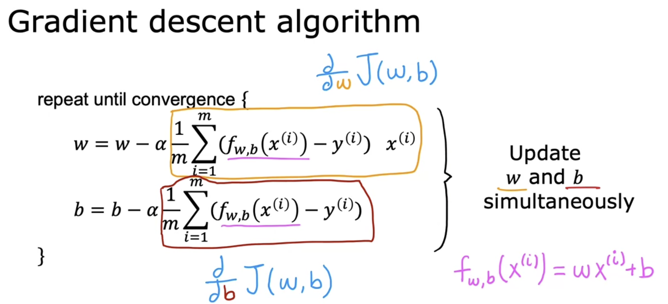

When using square errored cost function 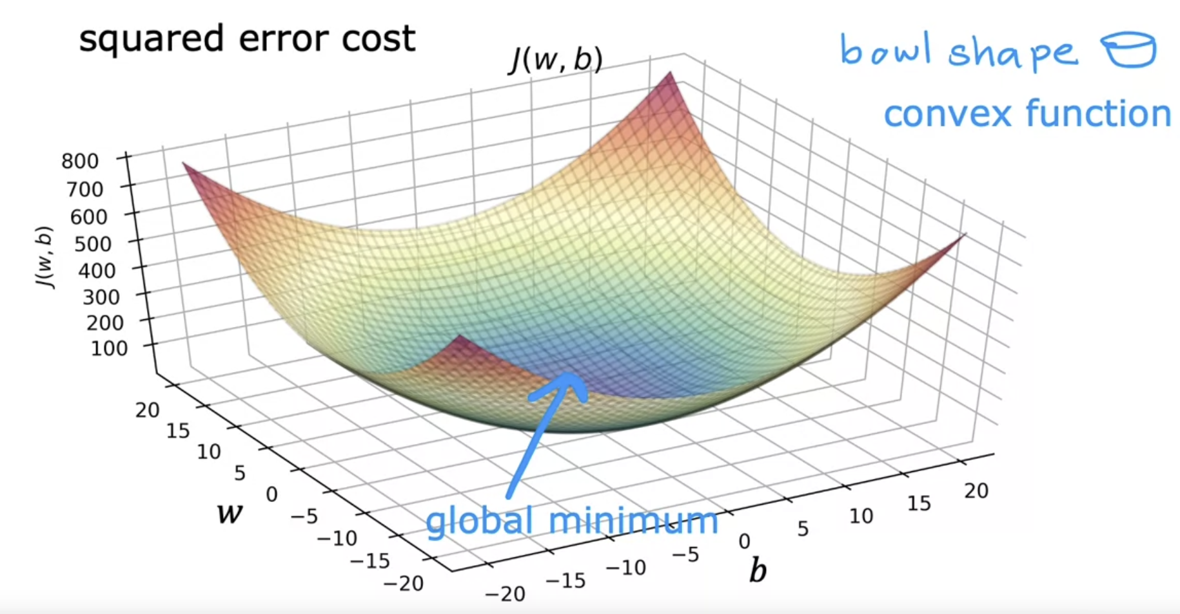

Convex function is a bowl shaped function which have only one global minimum and no local minimum it-self.  
When you implement gradient descent on a convex function, one nice property is that so long as you're learning rate is chosen appropriately, it will always converge to the global minimum.

# **Running Gradient Descent**

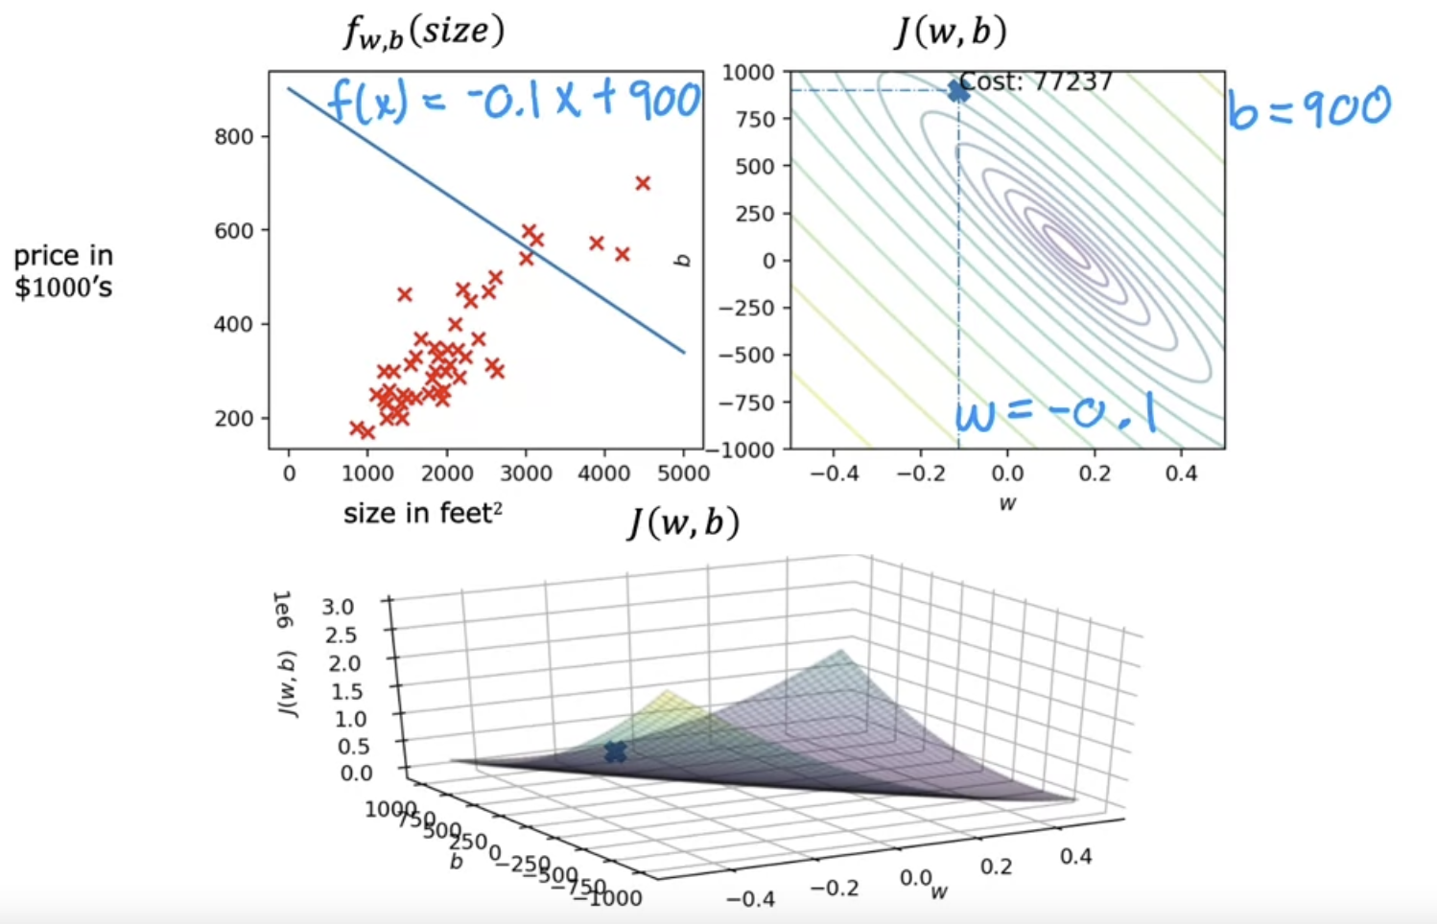

After running gradient descent,  
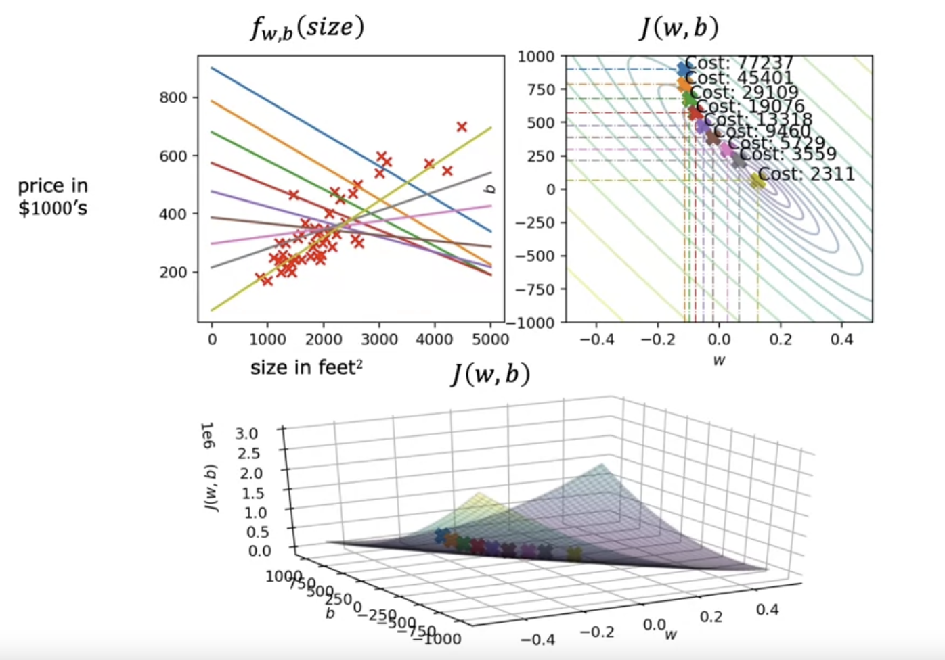

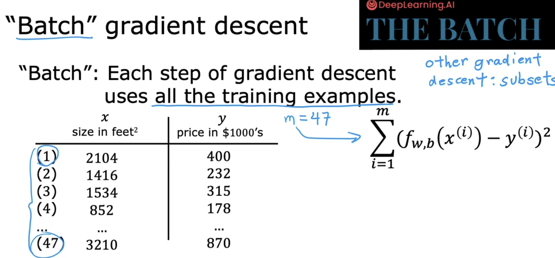

Refer 🡪 5_Gradient_Descent_Solution.ipynb

References

[Gradient descent | Coursera](https://www.coursera.org/learn/machine-learning/lecture/2f2PA/gradient-descent)

<https://www.cuemath.com/geometry/negative-slope/>